Lauderdale Profiles

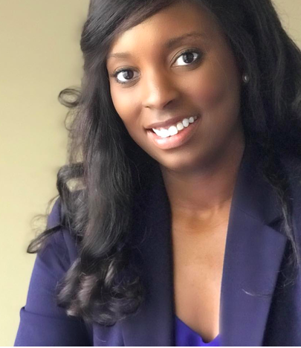
Whitney Maddox Dyer RHS ‘03
Attorney Whitney Dyer, Attorney at Law
Juris Doctor, Master’s in Secondary Education, Bachelor’s in Political Science
Samford University, University of Alabama at Birmingham, Miles College

Q: How did you select your college major, certification program, or career path?
A: Initially, I chose political science because of my interest in government and politics. During college, I suspected that I might decide to apply to law school, but after graduation I instead chose to accept a position with a large insurance company. After working for that company a few years, I realized that I felt unfulfilled in my corporate job, and wanted to do something that mattered more in the world. I knew that I would need to go back to school to gain the tools necessary to achieve my goals of making a difference in society.
Q: What was the biggest influence in your selection of career path?
A: I relied heavily on the advice of my close family members, and mentors. I asked them to give me their honest opinions on my strengths and weaknesses, and I would use this information to set my own personal goals. Listening to reliable advice was important to helping me avoid making costly mistakes.
Q: If you could go back to high school and select any elective course to take that would have better prepared you for college/career, what would it be?
A: Probably something related to communications or public speaking. Many people struggle with both verbal and non-verbal communication, and it is an essential skill in whatever career you pursue. Furthermore, one might say that it is directly tied to earning capacity.
Q: What is your favorite aspect of your job?
A: I enjoy helping people while working for myself
Q: How do you/your company make a positive impact on society/our community?
A: I serve on a local park board that supports community youth sports teams, and I also volunteer a regional natatorium (indoor pool) assisting with teaching swimming classes to adults of all ages.
Q: What’s the most interesting thing you have been able to do in your professional career?
A: I wouldn't be able to single out one thing, everyday provides its own new and interesting events.
Q: What makes you get up each morning excited about your profession?
A: As my own boss, I get to be as successful as I want to be every day. If I don't like something about my work, I have the power to change it.
Q: What advice would you share with K-12 students who are considering your profession?
A: Work on your verbal and written communication skills, and if possible join a debate team. Debate teams are excellent preparation for the critical thinking skills necessary to succeed in law school and beyond.
Q: What were some of the jobs you held as a young person (summer jobs, part time work, etc.), before you were on your career path? Did they play any part in your future occupation?
A: I was a cashier at the dollar tree in Ripley, and a shift manager at Krystal's in Dyersburg. I held these part-time jobs during and right after high school. These jobs taught me two things: 1) what type of job I did not want to have as an adult, and 2) that I needed to find a career that provided financial security.

